

task 3

DATA BASE MANAGEMENT SYSTEM



March 28, 2023

**AKHTAR ALI**

**34241**

**BSSE**

**Date: 28 March 2023**

**Submitted to sir waris ali**

* Query1:
* create table employee(empno number, name varchar(25));
* insert into employee(empno,name)

select empno,ename from emp;

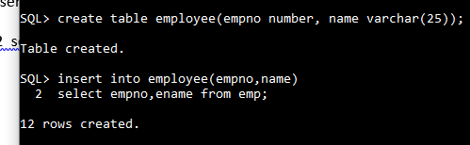

* Query 2:
* create table abc(nam,job,salary) as select ename,job,sal from emp

where job ='CLERK';

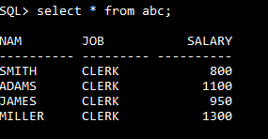

* Query 3:
* select sal,comm,NVL(comm,0) from emp;

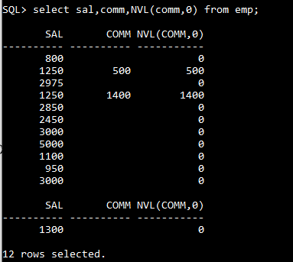

* Query 4:
* select sal,comm,sal+NVL(comm,0) from emp;

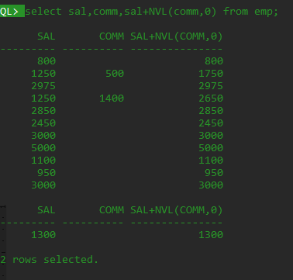

* Query 5:
* select sal,comm,NVL2(comm,sal+comm,sal) from emp;

work like if else statement.

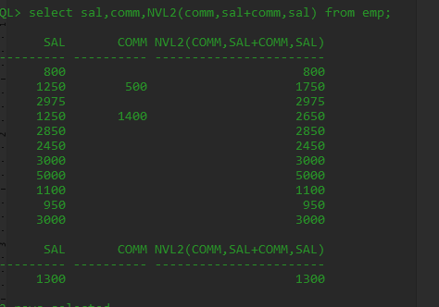

select ASCII('A'),ASCII('B'),ASCII('C') from dual;